Project Report – Student Leave Request Management
- INTRODUCTION

  - Project Overview
Educational institutions traditionally manage student leave requests through manual processes such as paper forms, emails, or verbal communication. These approaches often result in delayed approvals, poor record management, limited transparency, and difficulty in tracking the status of leave requests. Students frequently need to follow up with faculty members to determine whether their requests have been approved, while faculty members must manage multiple requests from different communication channels.
To address these challenges, this project presents the Student Leave Automation System, a web-based application developed on the ServiceNow platform. The application digitizes the complete leave approval process by providing a centralized workflow for students, Class Teachers, and Heads of Department (HODs). Students can submit leave requests through an intuitive interface, while faculty members can review, approve, reject, or manually escalate requests based on institutional policies.
The application implements role-based access control using ServiceNow roles, ensuring that students can access only their own leave requests while faculty members can manage requests assigned to them. Workflow automation is achieved through Flow Designer, which generates email notifications whenever a leave request is approved, rejected, or escalated. This improves communication, reduces administrative effort, and provides better visibility into the leave approval process.
The proposed system offers a scalable and paperless solution that enhances operational efficiency, improves user experience, and provides a structured approval workflow suitable for educational institutions.

1.2 Purpose

The primary purpose of the Student Leave Automation System is to replace the traditional manual leave approval process with a centralized digital solution developed on the ServiceNow platform. The system aims to simplify leave management by enabling students to submit requests online while providing faculty members with a structured workflow for reviewing and processing applications.
The specific objectives of the project are:
To provide a centralized platform for submitting and managing student leave requests.
To automate the leave approval workflow using ServiceNow Flow Designer.
To enable Class Teachers to approve, reject, or manually escalate leave requests to the Head of Department when required.
To provide separate Student and Faculty views with role-based access control.
To notify students through email whenever the status of their leave request changes.
To reduce paperwork, improve transparency, and enhance communication between students and faculty.
To demonstrate the practical implementation of ServiceNow application development concepts, including scoped applications, custom tables, Business Rules, Flow Designer, UI Policies, roles, and notifications.

- PROJECT OVERVIEW
2.1 Problem Statement
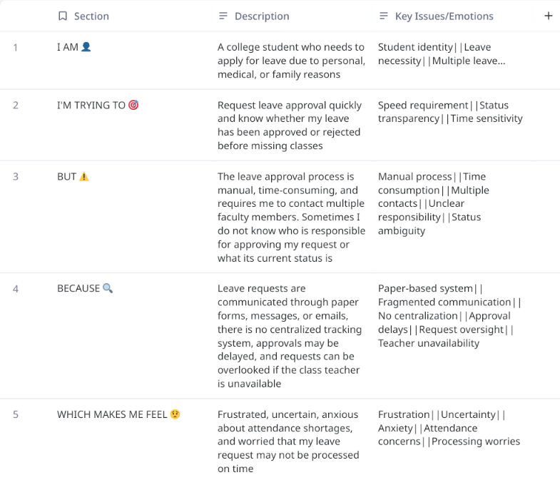

Problem Statement (PS) | I am (Customer) | I’m trying to | But | Because | Which makes me feel
PS-1 | A Student | Get my leave applications sorted out for my personal/medical reasons. | It is a very long process starting from paperwork making its way through the hierarchy. | Faculty/HOD’s aren’t always available, and they have their own schedules. | Tense, Annoyed, Unsure about my permissions.
PS-2 | Class Teacher | Complete all my duties on time for the students and others. | It also requires me personally signing their attendance letters. | Other faculty cannot directly award attendance without my consent at least. | Disappointed because I could not attend to the needy students.

2.2 Empathy Map Canvas
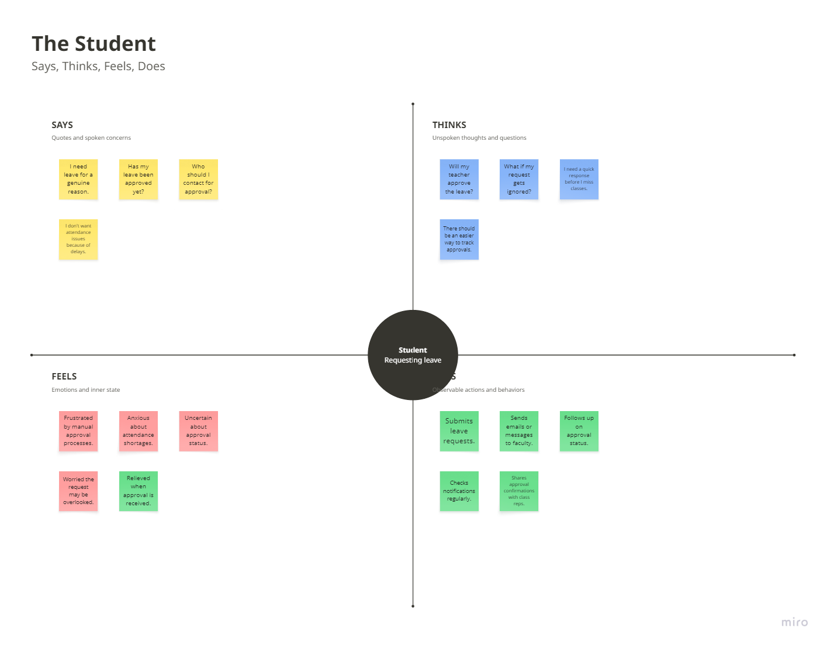

2.3 Brainstorming
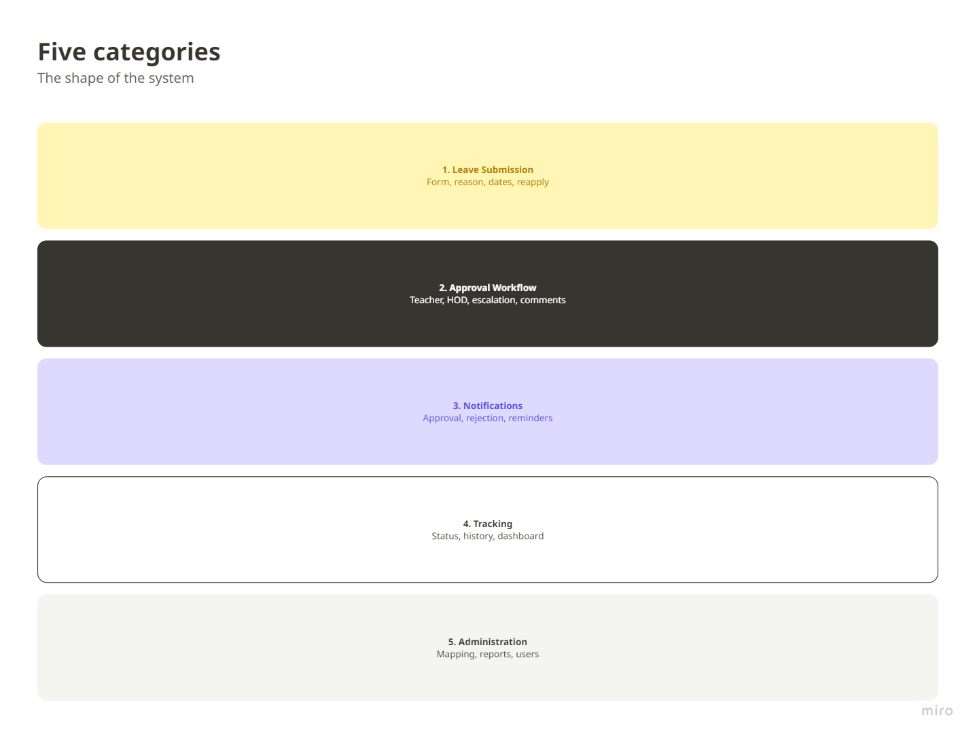

3. REQUIREMENT ANALYSYS
3.1 Customer Journey Map
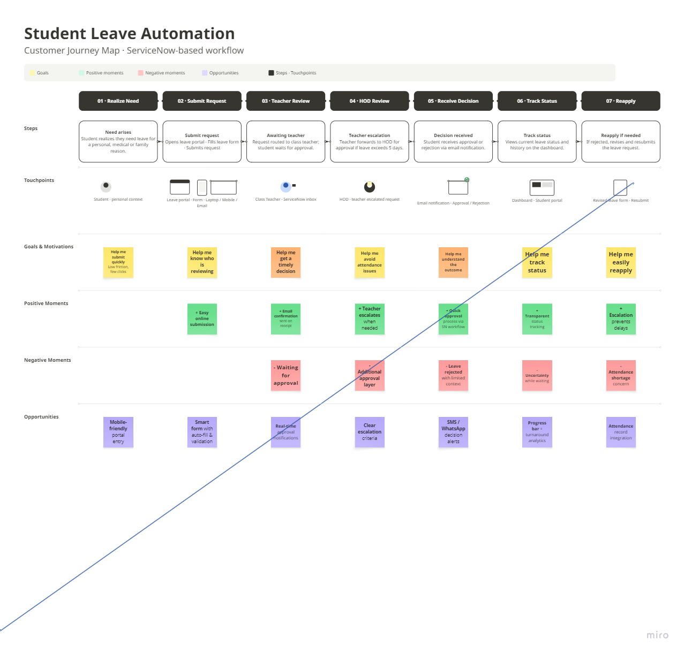

3.2 Solution Requirements
FR No. | Functional Requirement (Epic) | Sub Requirement (Story / Sub-Task)
FR-1 | User Authentication & Role Management | Authenticate users using the existing ServiceNow Users (sys_user) table.  Assign App User role to students.  Assign App Admin role to Class Teachers and HODs.
FR-2 | Leave Request Management | Students can create leave requests.
FR-3 | Leave Request Review and Response | Class Teachers can view assigned leave requests.  Approve requests up to five days.  Reject leave requests.  Manually escalate requests exceeding five days to the HOD.
FR-4 | HOD Approval functions | HOD can review escalated leave requests.  Approve leave requests.  Reject leave requests.  Modify the number of approved leave days before approval.
FR-5 | Workflow Automation | Trigger a Flow Designer workflow after every status change.  Send approval email.  Send rejection email.  Send escalation notification email

Non-functional Requirements:
Following are the non-functional requirements of the proposed solution.
FR No. | Non-Functional Requirement | Description
NFR-1 | Usability | The application shall provide intuitive Student and Faculty views with a simple and easy-to-use interface.
NFR-2 | Security | Access shall be controlled using ServiceNow roles. Students may access only their own leave requests, while faculty members may access only assigned requests.
NFR-3 | Reliability | The application shall accurately store leave requests and ensure workflow execution without data loss.
NFR-4 | Performance | Leave requests, approvals, and email notifications should be processed with minimal delay under normal usage.
NFR-5 | Availability | The application shall be available whenever the ServiceNow instance is operational.
NFR-6 | Scalability | The system shall support increasing numbers of students, faculty members, and leave requests without requiring major design changes.

3.3 Data Flow Diagram: A Data Flow Diagram (DFD) is a traditional visual representation of the information flows within a system. A neat and clear DFD can depict the right amount of the system requirement graphically. It shows how data enters and leaves the system, what changes the information, and where data is stored.

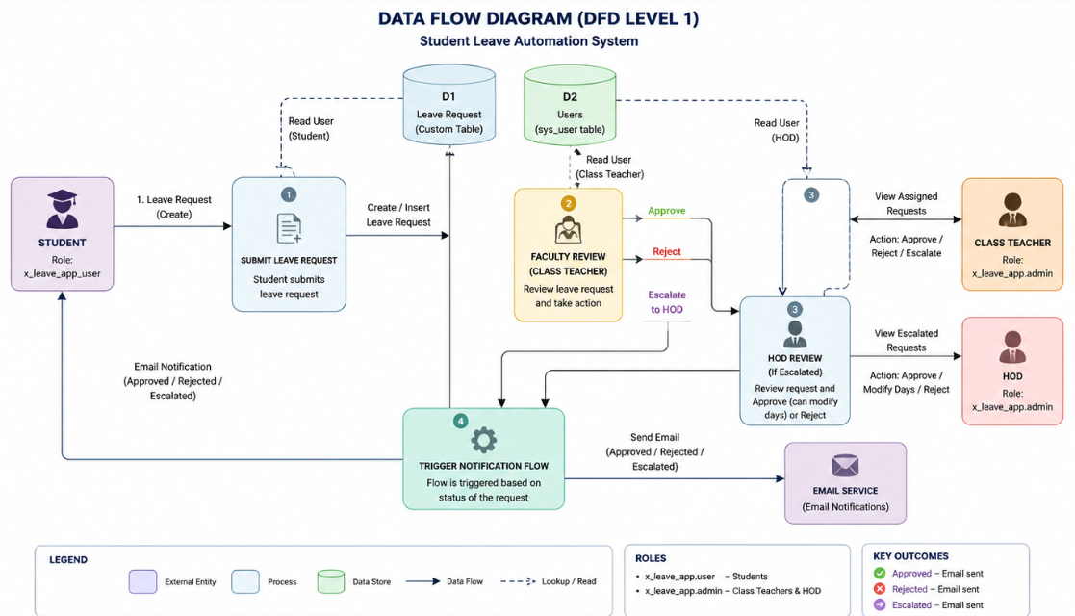

3.4 Technology Stack

Table 1: Components & Technologies
S.No | Component | Description | Technology
1 | User Interface | Student View & Faculty View | ServiceNow Workspace / Forms / Lists
2 | Application Logic | Leave submission & validation | Business Rules
3 | Workflow Automation | Approval workflow & notifications | Flow Designer
4 | Database | User identities and leave requests | sys_user, Custom Leave Request table
5 | Email Service | Approval / Rejection / Escalation emails | ServiceNow Notifications
6 | Security | Role-based access | ACLs, x_leave_app.user, x_leave_app.admin
7 | Infrastructure | Cloud platform | ServiceNow Cloud

Table 2: Application Characteristics
Characteristic | Description | Technology
Security | Role-based access for students and faculty | ACLs, Roles
Scalability | Supports increasing leave requests and users | ServiceNow Platform
Availability | Available whenever the ServiceNow instance is online | ServiceNow Cloud
Performance | Flow-based processing and lightweight forms | Flow Designer
Reliability | Centralized leave records and notifications | ServiceNow Database

4. PROJECT DESIGN
4.1 Problem Solution Fit
Section | Content
1. Customer Segment(s) | • College Students • Class Teachers • Head of Department (HOD)
2. Jobs-to-be-done / Problems | • Apply for leave quickly • Get timely approval • Track leave status • Reduce paperwork • Enable efficient faculty approval
3. Triggers | • Student needs leave due to illness, family emergency, or personal reasons • Upcoming exams or attendance concerns • Faculty receives a new leave request
4. Emotions (Before / After) | Before: Frustrated, uncertain, anxious about attendance. After: Confident, informed, satisfied, stress-free.
5. Available Solutions | • Paper leave forms • WhatsApp messages • Emails • Verbal requests through Class Representatives • Manual approval process
6. Customer Constraints | • No centralized tracking • Delayed approvals • Limited communication • Students unaware of request status • Faculty managing requests from multiple channels
7. Behaviour | • Students contact teachers via WhatsApp or email • Follow up repeatedly • Faculty reviews requests manually • Students wait for responses or reminders
8. Channels of Behaviour | Online: College portal, ServiceNow application, Email. Offline: Direct interaction with Class Teacher, HOD, or Class Representative.
9. Problem Root Cause | The college lacks a centralized leave management workflow. Leave requests are processed manually through different communication channels, resulting in delays, poor visibility, and inconsistent tracking.
10. Your Solution | Develop a ServiceNow Student Leave Automation System where students submit leave requests online. Requests are routed to the Class Teacher, who can approve, reject, or manually escalate requests exceeding five days to the HOD. HOD can approve, reject, or modify approved leave days. Flow Designer automatically sends email notifications whenever the leave status changes, and students can track the status of their requests through the application.

4.2 Proposed Solution

S.No | Parameter | Description
1 | Problem Statement (Problem to be solved) | Colleges often manage student leave requests manually through paper forms, emails, or verbal communication. This leads to delayed approvals, lack of transparency, difficulty in tracking request status, and inefficient communication between students and faculty.
2 | Idea / Solution Description | Develop a ServiceNow-based Student Leave Automation System where students submit leave requests digitally. Requests are reviewed by the Class Teacher, who can approve, reject, or manually escalate requests exceeding five days to the HOD. The HOD can approve, reject, or modify approved leave days. Flow Designer automatically sends email notifications for approved, rejected, and escalated requests, while students can track their leave status through dedicated application views.
3 | Novelty / Uniqueness | The solution combines role-based access control, manual approval workflow, digital leave tracking, email notifications, and separate Student and Faculty views within a single ServiceNow application. It eliminates paper-based processing while keeping approval decisions under faculty control.
4 | Social Impact / Customer Satisfaction | The application improves transparency, reduces paperwork, minimizes approval delays, and enhances communication between students and faculty. Students receive timely updates, while faculty members can efficiently manage leave requests through a centralized platform.
5 | Business Model (Revenue Model) | The solution is intended for educational institutions as an internal digital service. It can be adopted by colleges or universities as part of their campus management system. Future deployment could follow a Software-as-a-Service (SaaS) subscription model for multiple institutions.
6 | Scalability of the Solution | The application is built on the ServiceNow platform and can scale to support multiple departments, academic years, and institutions. Additional modules such as attendance integration, parent notifications, academic calendars, and analytics dashboards can be incorporated without major architectural changes.

4.3 Solution Architecture

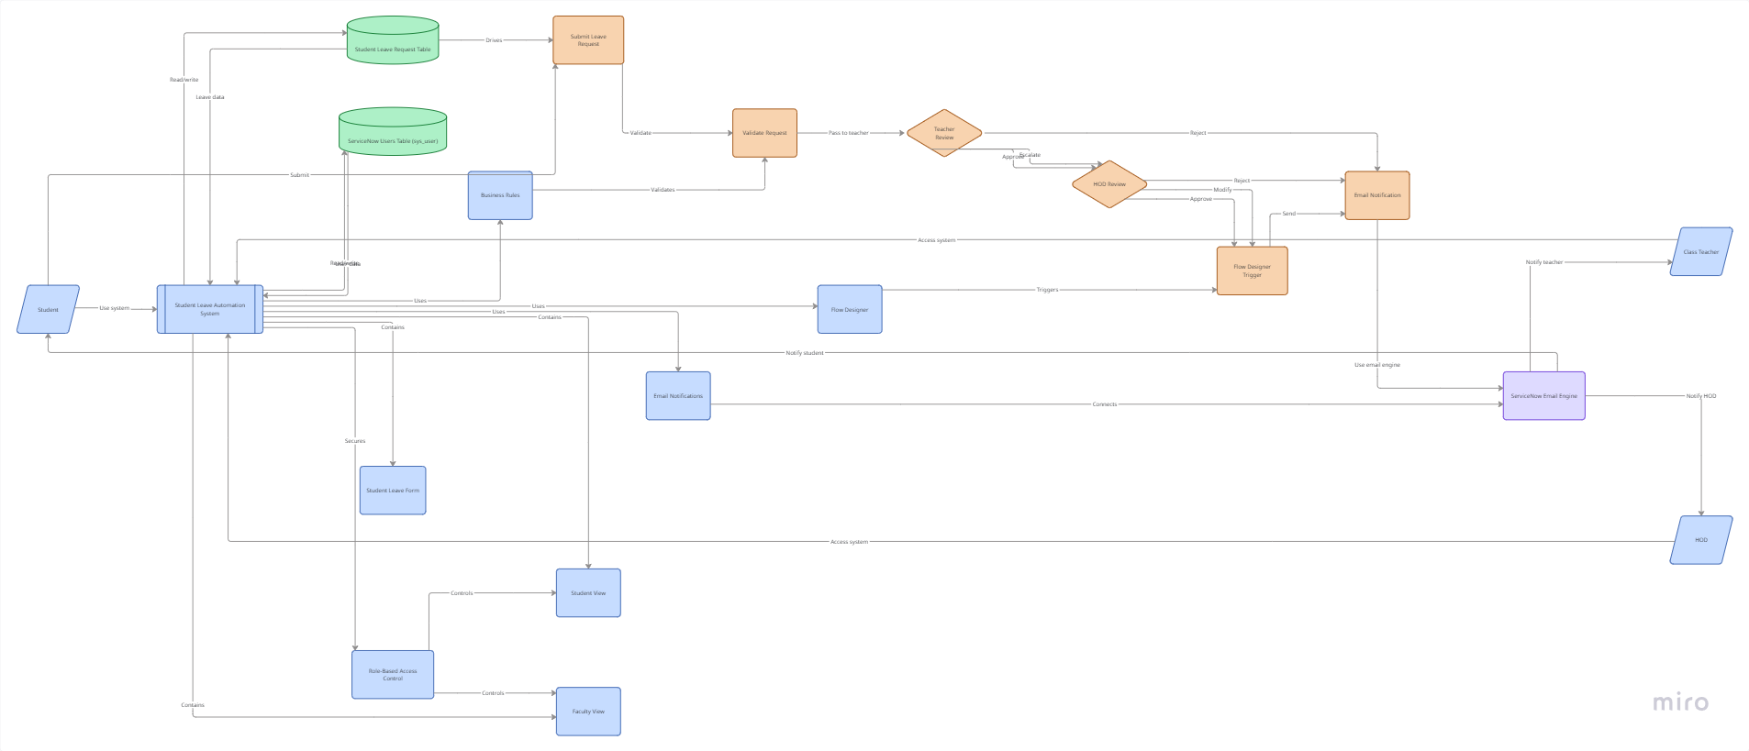

5. PROJECT PLANNING & SCHEDULING
Product Backlog, Sprint Schedule, and Estimation
Sprint | Functional Requirement (Epic) | User Story Number | User Story / Task | Story Points | Priority
Sprint-1 | Project Setup | USN-1 | Create scoped application, roles, Leave Request table, Student View, leave submission | 8 | High
Sprint-2 | Approval Workflow | USN-2 | Faculty View, Class Teacher approval, rejection, manual escalation to HOD | 9 | High
Sprint-3 | HOD and Notifications | USN-4 | HOD approval, modify leave days, Flow Designer, email notifications | 8 | Medium
Sprint-4 | Testing and Documentation | USN-5 | Testing, bug fixes, reports, final documentation, presentation | 5 | High

Project Tracker, Velocity & Burndown Chart: (4 Marks)
Sprint | Total Story Points | Duration | Sprint Start Date | Sprint End Date (Planned) | Story Points Completed (as on Planned End Date) | Sprint Release Date (Actual)
Sprint-1 | 8 | 2 Days | 22 June 2026 | 23 June 2026 | 8 | 23 June 2026
Sprint-2 | 9 | 2 Days | 24 June 2026 | 25 June 2026 | 9 | 25 June 2026
Sprint-3 | 8 | 2 Days | 26 June 2026 | 27 June 2026 | 8 | 27 June 2026
Sprint-4 | 5 | 1 Day | 28 June 2026 | 28 June 2026 | 5 | 28 June 2026

Velocity:

- Total Story Points: 30
- Total Duration: 7 days
Average Velocity = 30 ÷ 7 ≈ 4.3 story points/day

6. FUNCTIONAL AND PERFORMANCE TESTING
2. Milestone 1 – Application Setup
Objective
Create the scoped application and initialize the project.
Activities Performed
- Created a new scoped application.
- Configured the application menu and modules.
- Prepared the development environment.
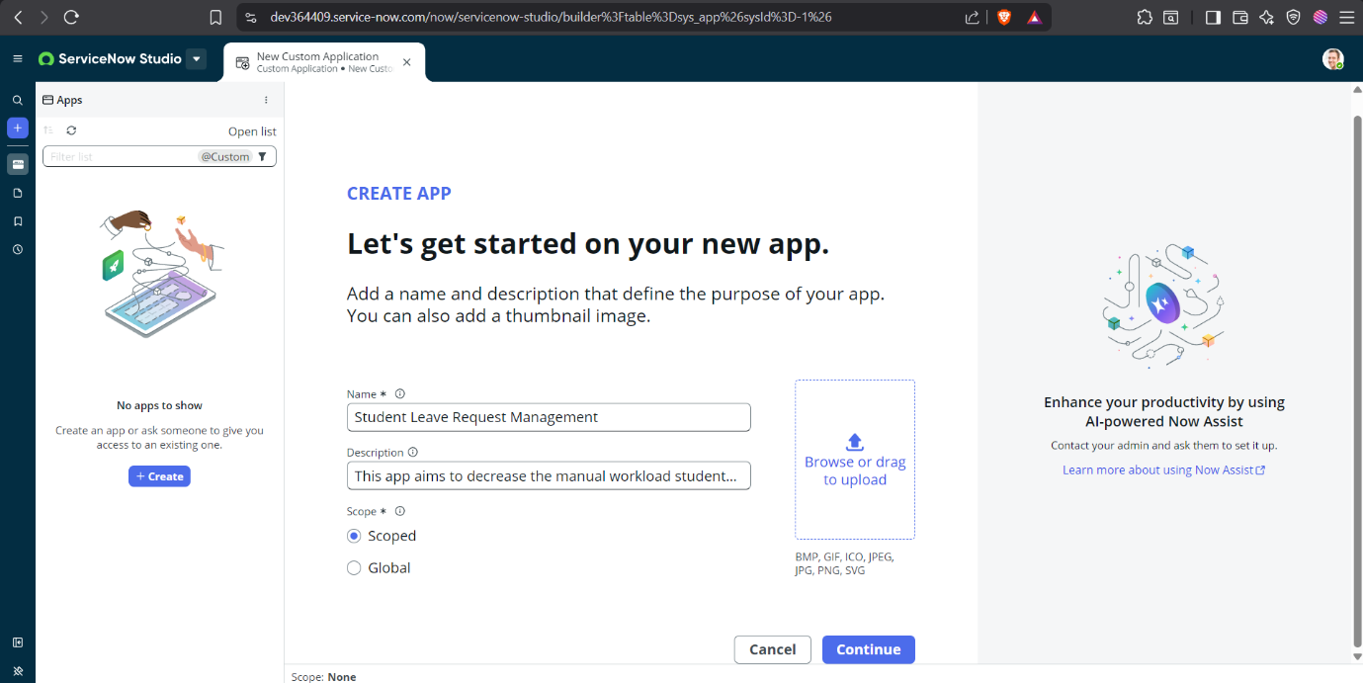

3. Milestone 2 – Database Configuration
Objective
Create the Leave Request table for storing leave applications.
Activities Performed
- Designed the Leave Request table.
- Added fields such as Student, Class Teacher, HOD, Leave Type, From Date, To Date, Status, Approved Days, and Comments.
- Configured reference fields to the ServiceNow Users table (sys_user).
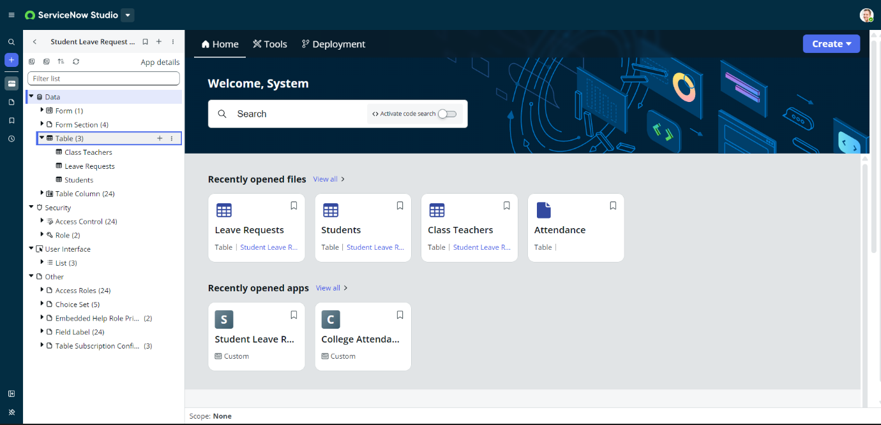
4. Milestone 3 – User & Role Configuration
Objective
Configure users and application roles.
Activities Performed
- Created student user accounts.
- Created faculty user accounts.
- Assigned App User role to students.
- Assigned App Admin role to Class Teachers and HODs.
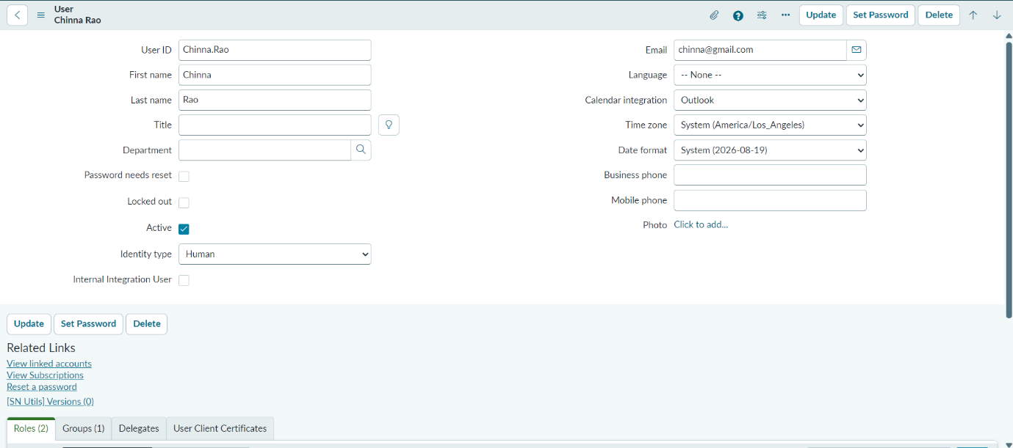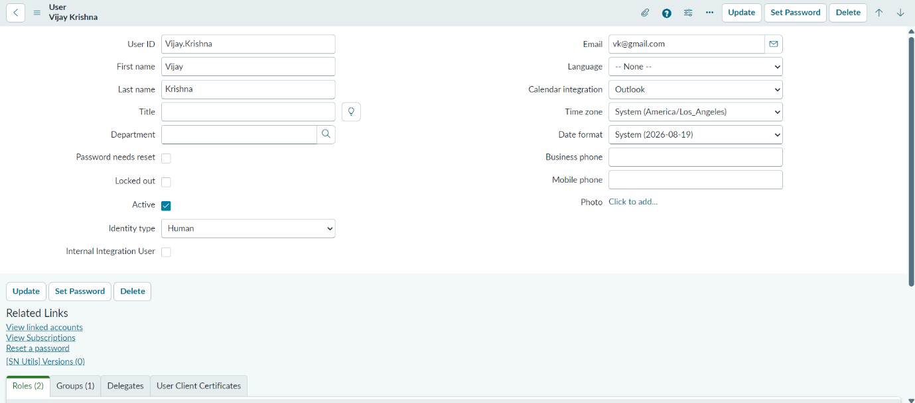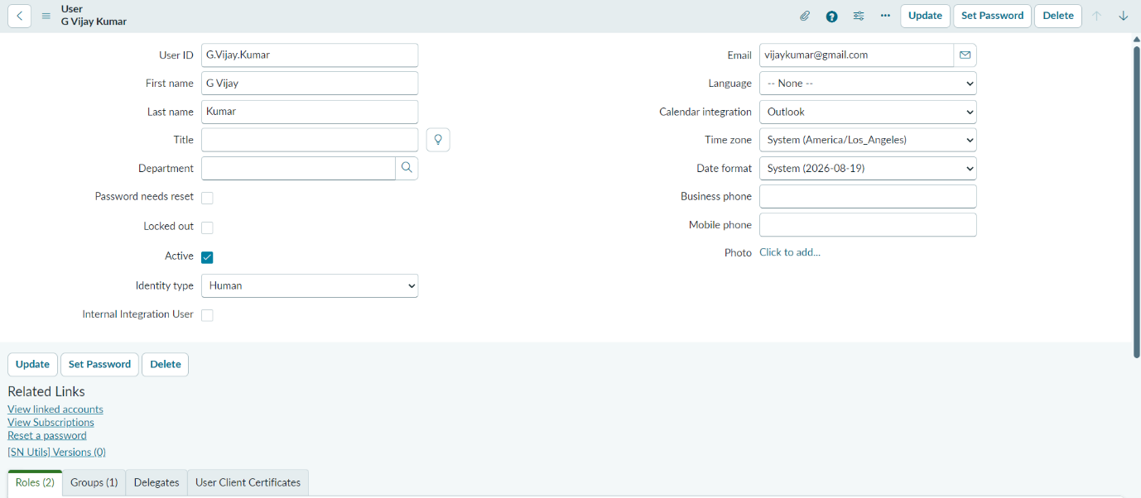
5. Milestone 4 – User Interface Development
Objective
Develop user-friendly interfaces for students and faculty.
Activities Performed
- Designed the Student Leave Request form.
- Configured separate Student and Faculty views.
- Implemented UI Policies for dynamic form behavior.
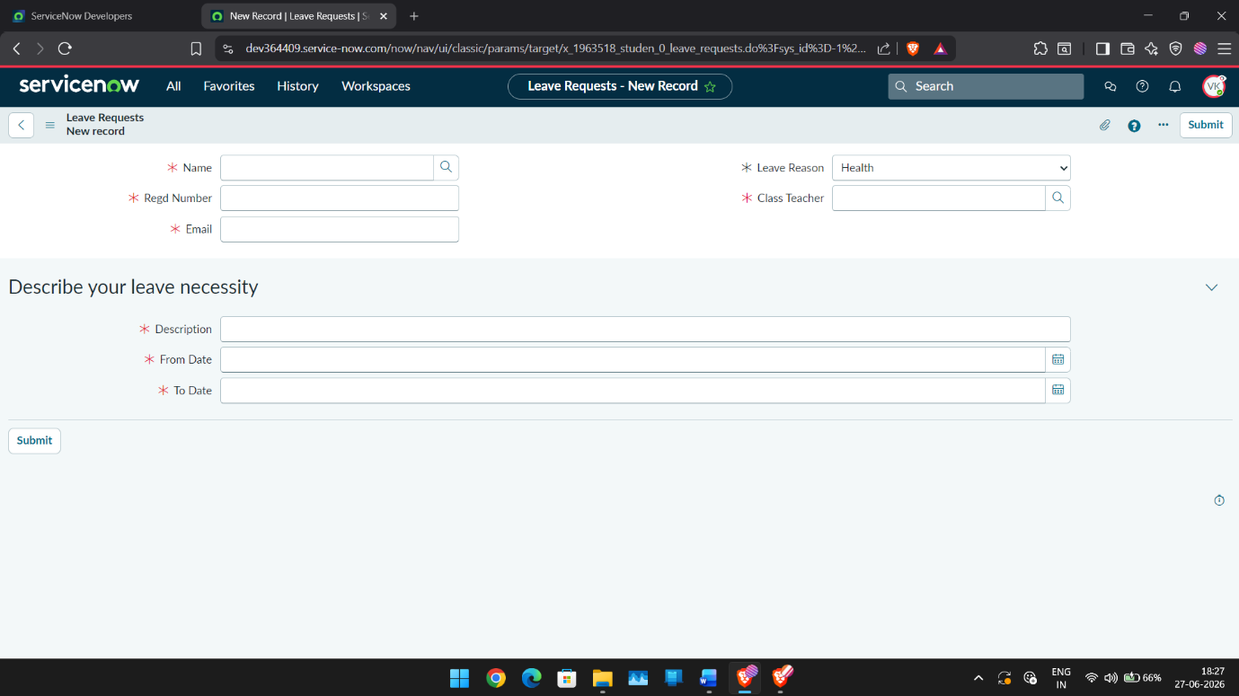
6. Milestone 5 – Workflow Automation
Objective
Automate leave approval notifications.
Activities Performed
- Developed a Flow Designer workflow.
- Triggered the workflow whenever the leave status changes.
- Configured notification logic for Approved, Rejected, and Escalated states.
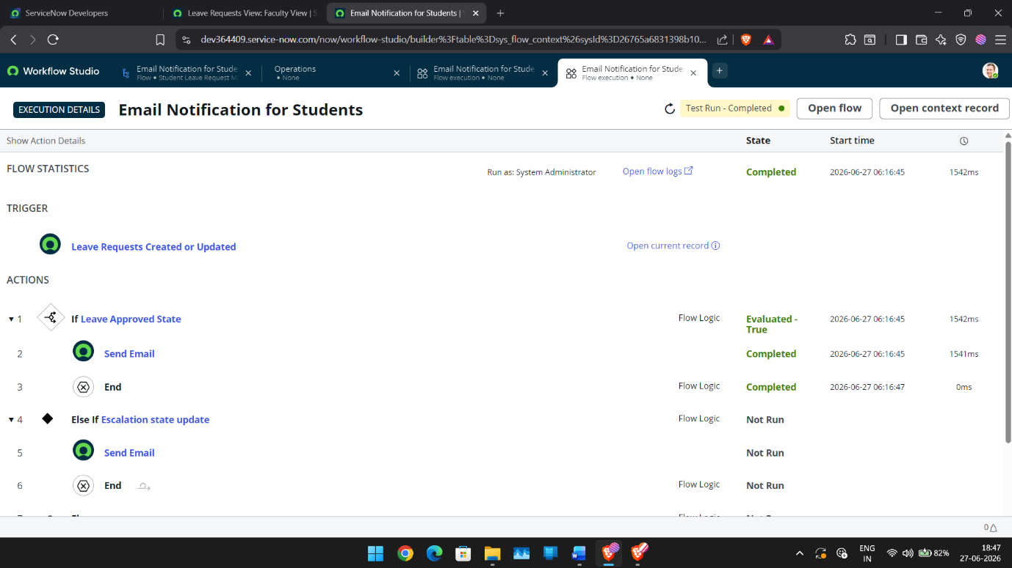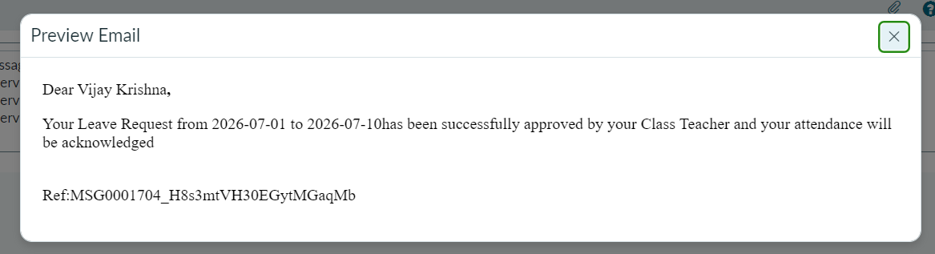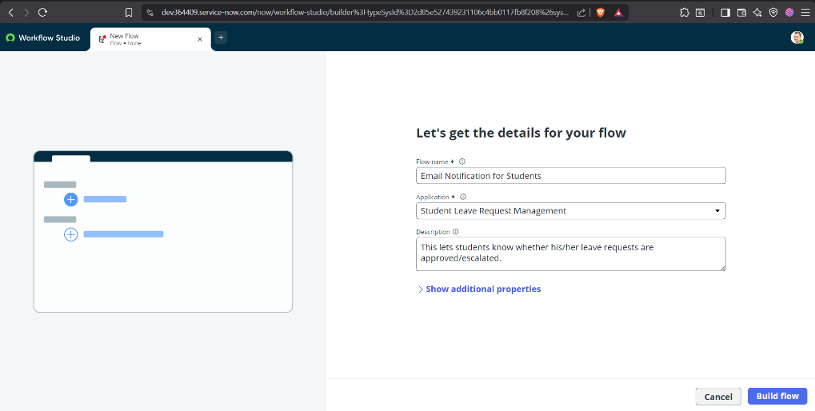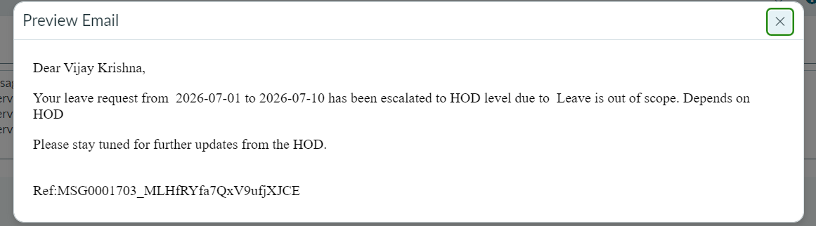

7. Milestone 6 – Application Testing
Objective
Validate the end-to-end functionality of the application.
Test Scenario 1
Student submits a leave request.
Expected Result:
Leave request is created successfully.
Status:
Passed
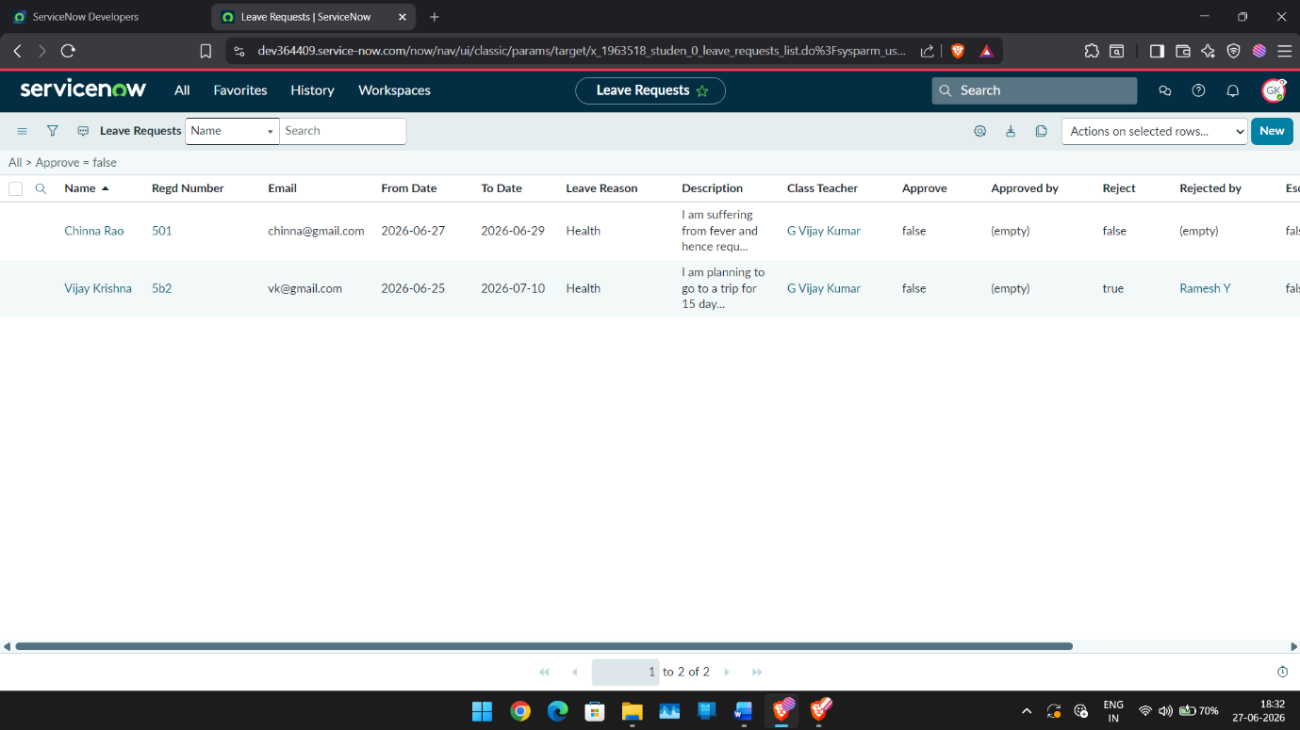

Test Scenario 2
Class Teacher approves a leave request.
Expected Result:
Status changes to Approved and an email notification is sent.
Status:
Passed

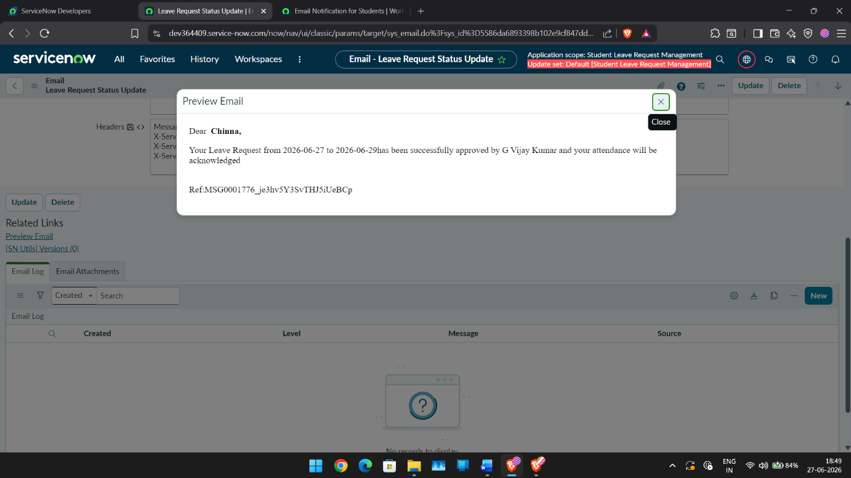

Test Scenario 3
Class Teacher manually escalates a leave request exceeding five days.
Expected Result:
Request is forwarded to the HOD and an escalation email is sent.
Status:
Passed



Test Scenario 4
Faculty impersonation testing.
Expected Result:
Faculty can only access assigned leave requests.
Status:
Passed
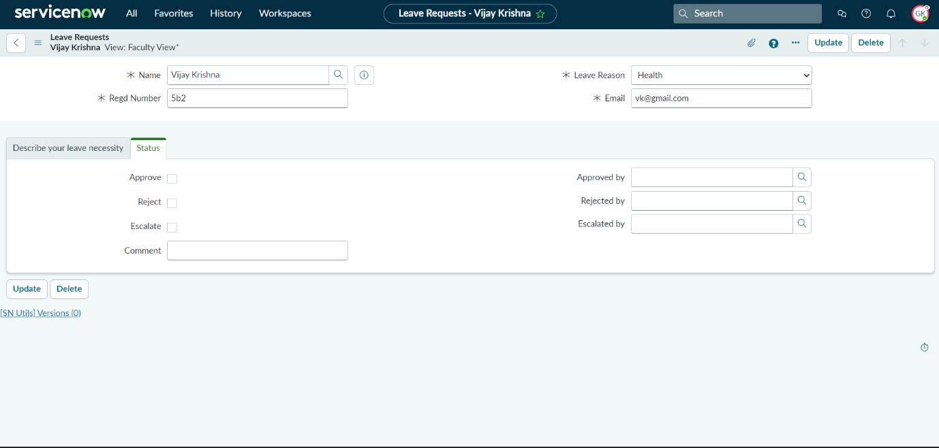

8 Development Summary
The Student Leave Automation System successfully implements a centralized leave management workflow using ServiceNow. The application integrates role-based access control, separate student and faculty interfaces, workflow automation through Flow Designer, and email notifications. All major functional requirements were implemented and validated through successful testing.

7. RESULTS




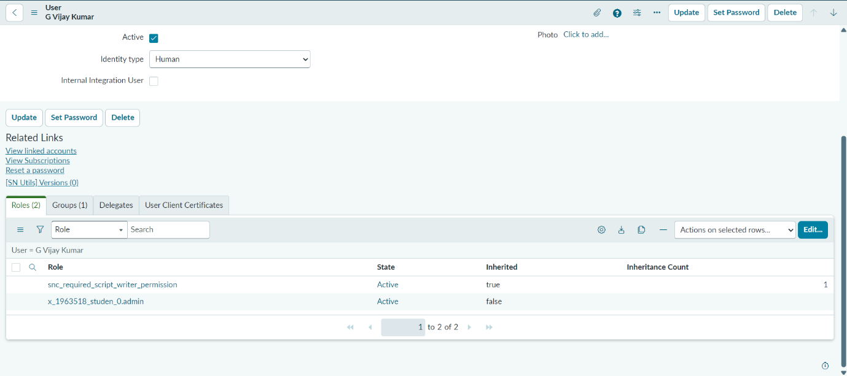

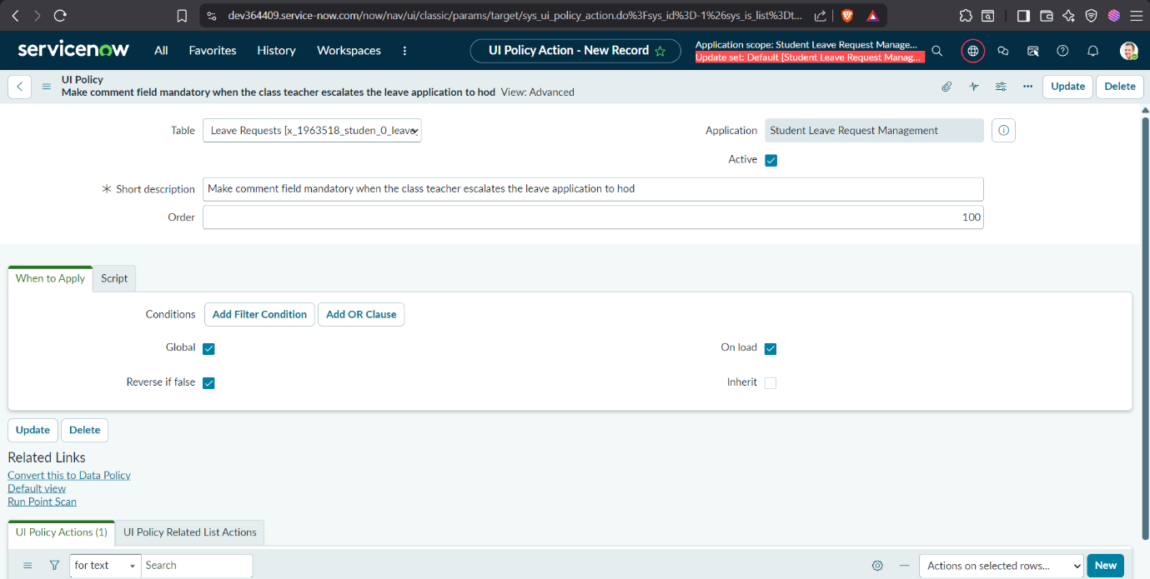

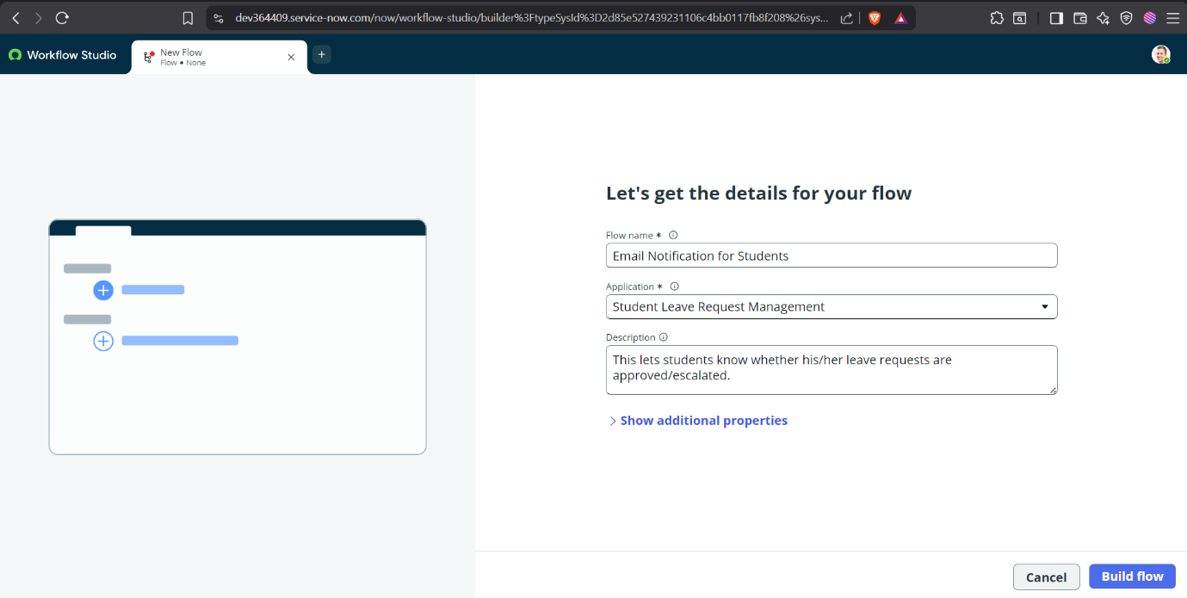







8. ADVANTAGES AND DISADVANTAGES
Advantages
- Paperless Leave Management
Eliminates paper forms and manual documentation by digitizing the entire leave request process.
- Centralized Leave Tracking
All leave requests are stored in a single system, making it easy for students and faculty to access and manage records.
- Role-Based Access Control
Students can access only their own leave requests, while faculty members can review and manage requests assigned to them.
- Improved Transparency
Students can view the status of their leave requests, reducing uncertainty and the need for repeated follow-ups.
- Automated Email Notifications
The system automatically sends email notifications when a leave request is approved, rejected, or escalated.
- Efficient Approval Workflow
Class Teachers can process leave requests directly and manually escalate requests exceeding five days to the HOD when necessary.
- Reduced Administrative Workload
Faculty members can manage leave requests through a centralized interface instead of handling requests via multiple communication channels.
- Secure User Management
User authentication is handled through the existing ServiceNow Users (sys_user) table with application-specific roles.
- Scalable Architecture
The application can be extended to support multiple departments, additional approval levels, or integration with other campus systems.
- Easy Maintenance
Since the application is built on the ServiceNow platform using configurable components such as Flow Designer and Business Rules, future modifications can be implemented with minimal effort.
Disadvantages
- Requires ServiceNow Platform
The application depends on a ServiceNow instance and cannot operate independently without the platform.
- Internet Dependency
Users must have an active internet connection to submit, review, or approve leave requests.
- Manual Escalation Required
Leave requests exceeding five days require the Class Teacher to manually forward them to the HOD, which relies on timely faculty action.
- Limited to Institutional Workflow
The application is designed specifically for student leave management and requires customization for use in other domains.
- Initial User Configuration
Student and faculty accounts, roles, and reference fields must be configured before the system can be used effectively.
- Email Delivery Dependency
Notifications depend on proper email configuration within the ServiceNow instance.
- No Attendance Integration
The current implementation does not automatically synchronize approved leave with the institution's attendance management system.
- Limited Reporting Features
Basic reporting is supported, but advanced analytics and dashboards require further development.

9. CONCLUSION
The Student Leave Automation System successfully demonstrates how the ServiceNow platform can be utilized to digitize and streamline the student leave approval process within educational institutions. The application replaces traditional manual methods with a centralized, role-based system that enables students to submit leave requests online while allowing Class Teachers and Heads of Department (HODs) to efficiently review, approve, reject, or manually escalate requests based on institutional policies. Through the implementation of ServiceNow features such as scoped applications, custom tables, Business Rules, Flow Designer, UI Policies, roles, and email notifications, the system provides a structured and transparent workflow that improves communication and reduces administrative effort.
The project successfully achieved its primary objectives by providing a secure, user-friendly, and scalable leave management solution. Functional testing verified that all major features—including leave submission, approval workflow, manual escalation, status tracking, and automated email notifications—performed as expected. Overall, the proposed solution enhances operational efficiency, improves the user experience for both students and faculty, and serves as a strong foundation for future enhancements such as attendance integration, mobile access, analytics dashboards, and advanced reporting capabilities.

10. FUTURE SCOPE
The Student Leave Automation System provides a strong foundation for digital leave management and can be further enhanced with additional features to improve functionality and user experience. Future enhancements may include integration with the institution's attendance management system to automatically update attendance records after leave approval, eliminating manual intervention. The application can also be extended with a dedicated mobile interface, enabling students and faculty to submit and review leave requests from smartphones.
Additional improvements include implementing analytics dashboards to monitor leave trends, department-wise statistics, and approval turnaround times. The system can be integrated with academic calendars to validate leave requests against examination schedules and institutional holidays. Multi-level approval workflows can be introduced for larger institutions requiring approvals from additional authorities. Furthermore, SMS or mobile push notifications can complement email notifications for faster communication. These enhancements would make the application more comprehensive, scalable, and suitable for deployment across multiple educational institutions while continuing to improve administrative efficiency and the overall user experience.

APPENDIX
INTRODUCTION 01
IDEATION PHASE 02
REQUIREMENT ANALYSIS 05
PROJECT DESIGN 09
PLANNING AND SCHEDULING 12
FUNCTIONAL AND PERFORMANCE TESTING 13
RESULTS 21
ADVANTAGES AND DISADVANTAGES 26
CONCLUSION 28
FUTURE SCOPE 28

